APPLICATION SUMMARY

PERMANENT CHANGE TO A LIQUOR PRIMARY LIQUOR LICENSE

LIQUOR LICENSE APPLICATION NO. LA000111 – 241 SKINNER STREET

Establishment Name: Club 241

Applicant/Owner: Mr. Brent Mark on behalf of Gurdev Holdings Ltd. (Mr. Paul Manhas)

Zoning: DT1 - Core

PURPOSE:

The purpose of this report is to advise Council of an application received from Mr. Brent Mark for Club 241 (241 Skinner Street) to increase the licensed area capacity of the nightclub from 244 persons to 272 persons in advance of Staff requesting comments from adjacent property owners and occupants. As Council is aware, a municipal resolution is required before the Province will consider the application further.
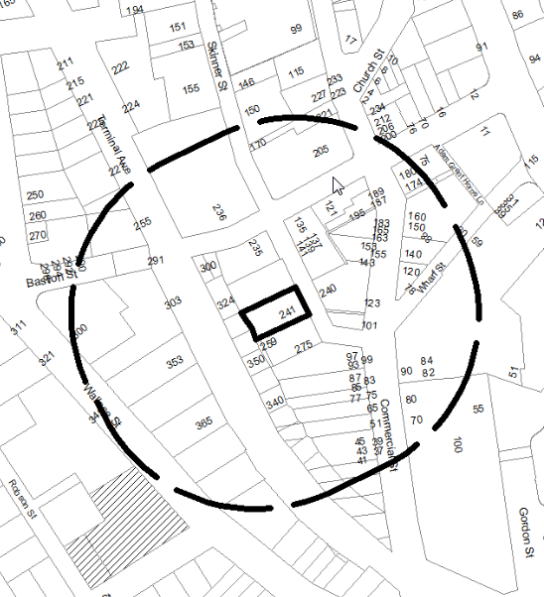
Map 1 – General City Location
BACKGROUND:

The City has received correspondence from Mr. Brent Mark (Club 241). The applicant is requesting a local government resolution in support of his application to the Provincial Liquor Control and Licensing Branch (LCLB) to increase the licensed capacity for an existing nightclub from 244 persons to 272 persons.

DISCUSSION:

At its meeting of 2014-OCT-06, Council endorsed an amendment to the application process for permanent changes to liquor primary and food primary licenses to use a Council posting procedure to notify Council of a liquor licence application; as such, this application summary is being posted in place of the Information Only Council report Council previously received.

A public notice and comment sheet will be mailed and delivered to all of the owners and occupants of buildings and properties surrounding the subject location at 241 Skinner Street. A referral request will also be sent to the Downtown Nanaimo Business Improvement Association (DNBIA). All referral responses, including comments from the RCMP and the DNBIA, will be summarized and attached to a future report.

DS/ pm Prospero: LA111

